**Project Name: My Portfolio Easy Way To Create Your Amazing Portfolio**

**Developer Name:** Kapil Davey

**GitHub Link: https://github.com/kapildavey/Phase-4.git**

**Output:**

**Signin.component.html**

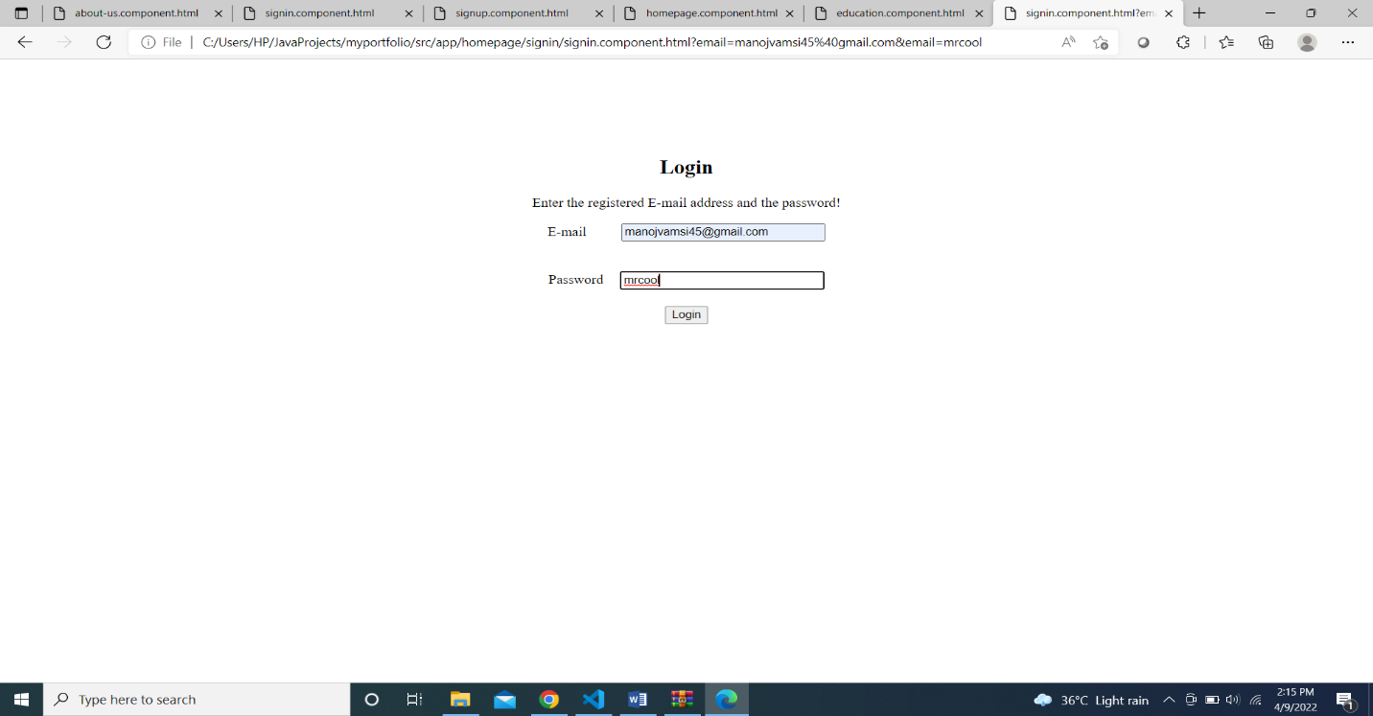

**Signup.component.html**

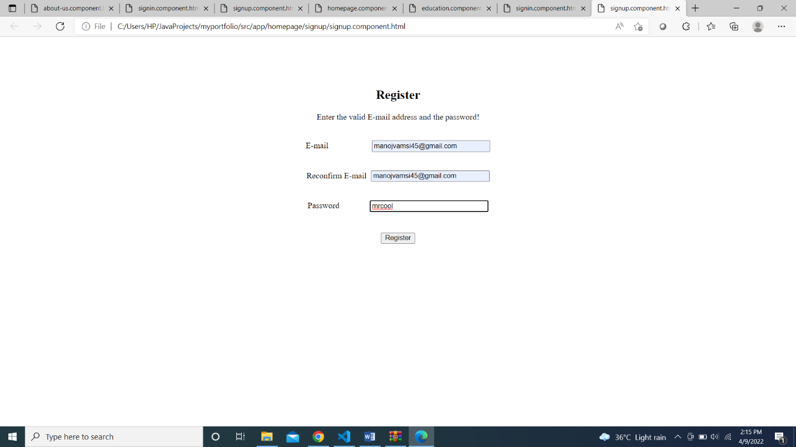

**Home.component.html**

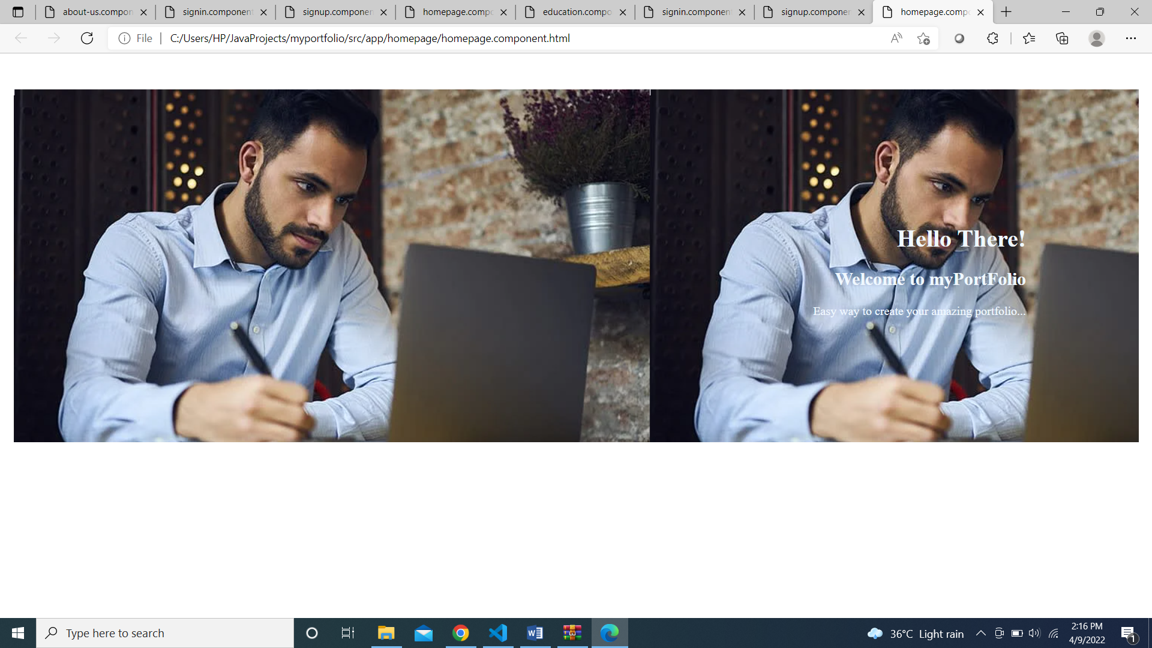

**Header.component.html**

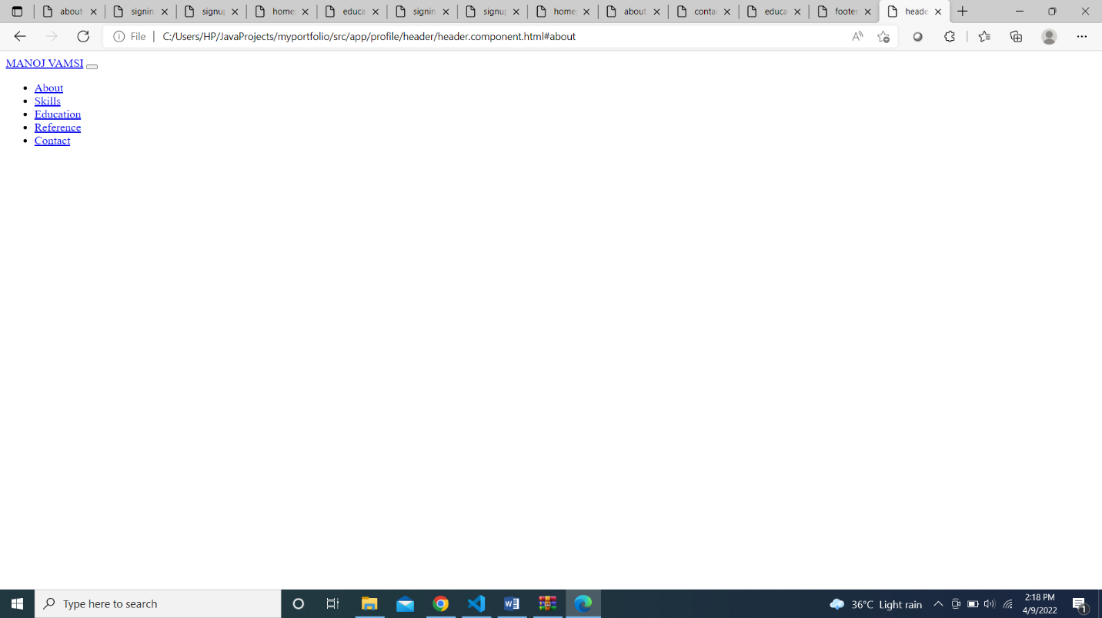

**About.component.html**

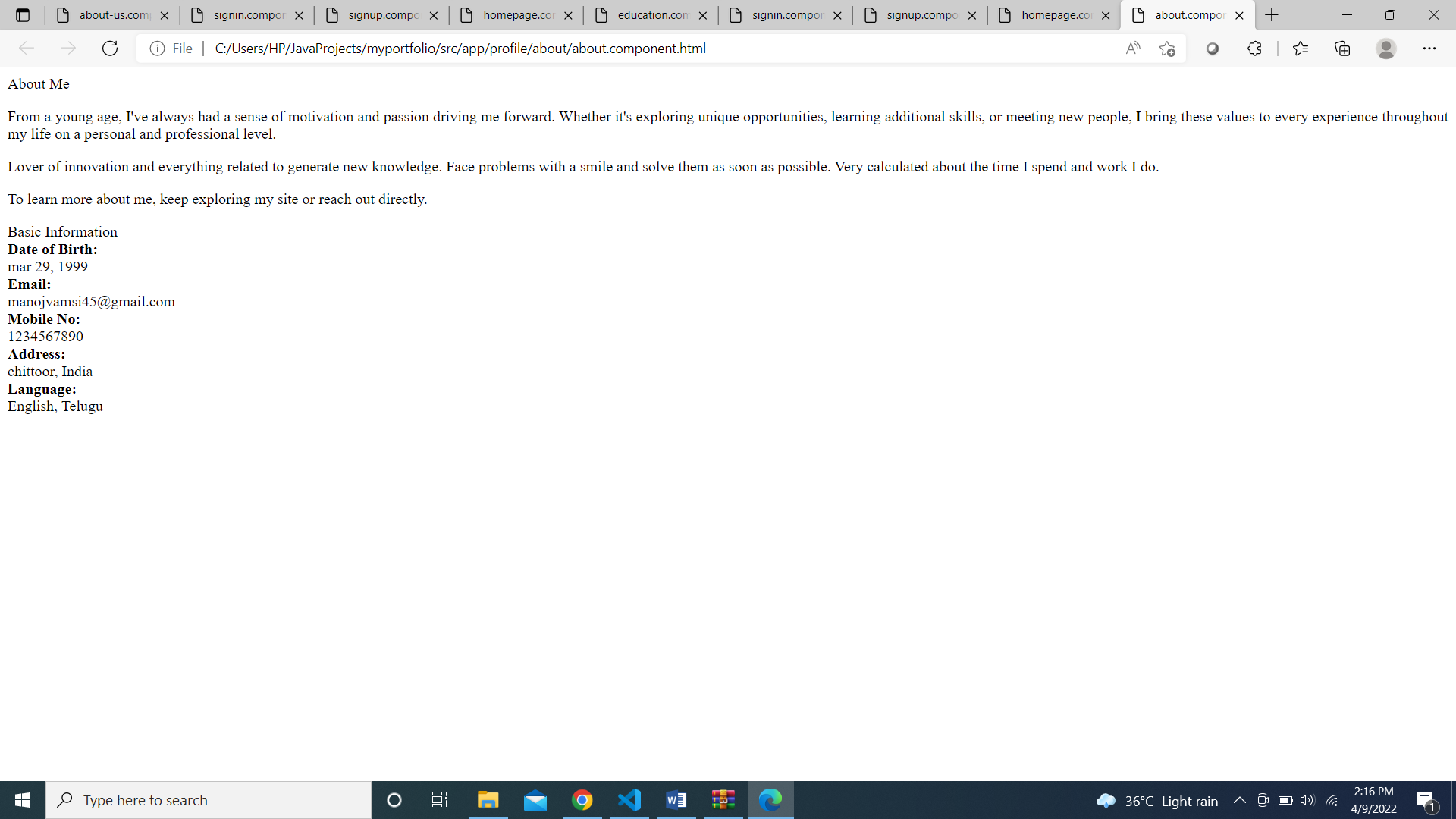

**Contact.component.html**

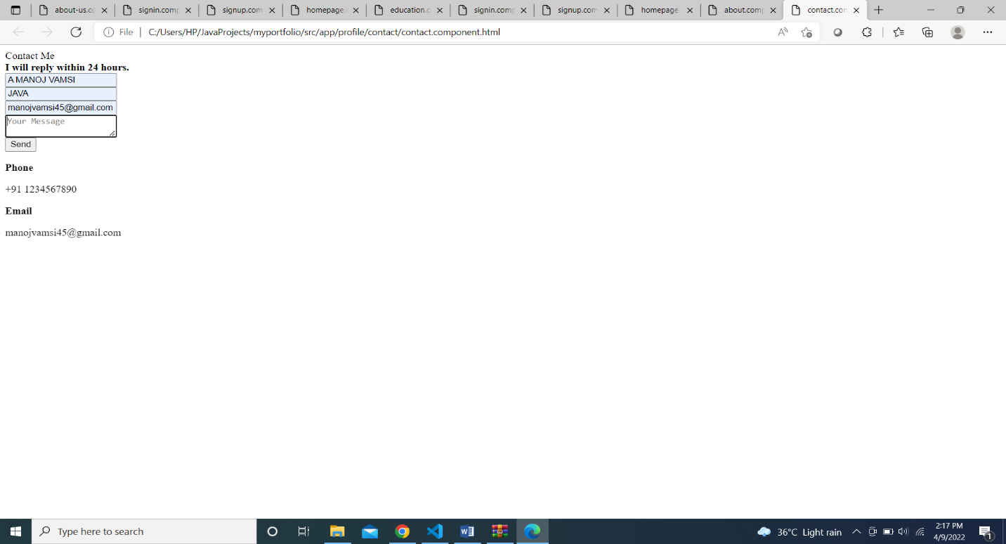

**Education.component.html**

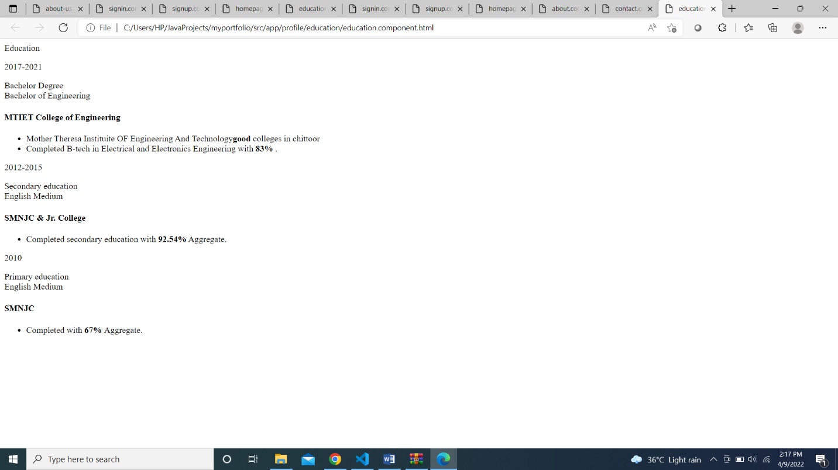

**Intro.component.html**

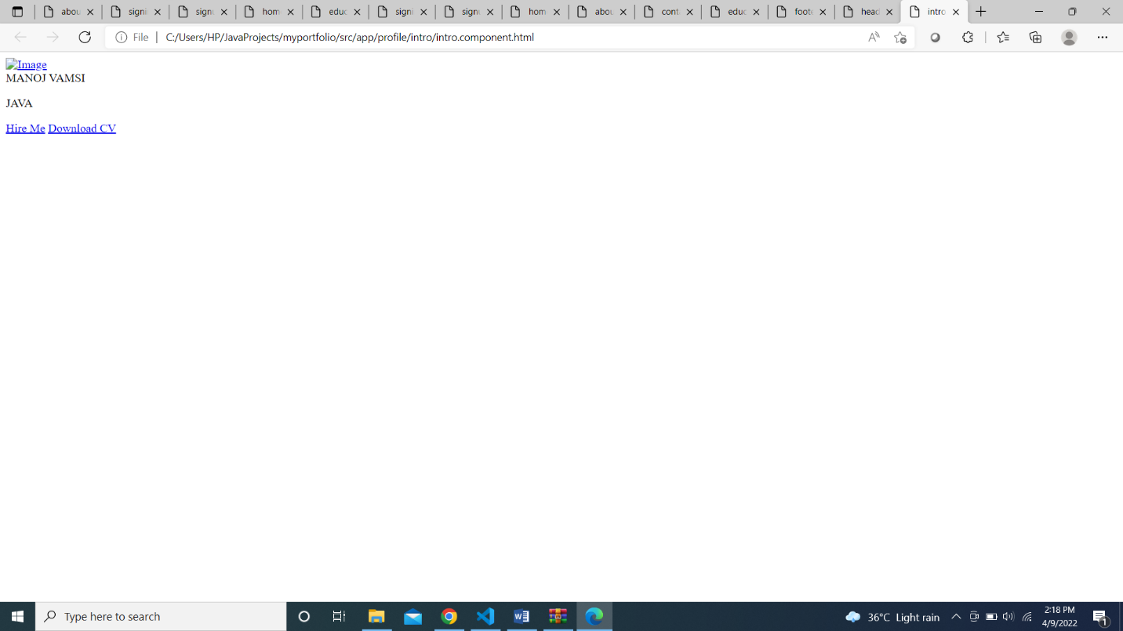

**Skills.componemt.html**

